Data Structures and Algorithms
Week 6 problem sheet

A. ADTs
- Which of the following are ADTs and which are concrete data types?
  - array
  - linked listy
  - graph
  - binary search tree
  - queue
  - priority queue
  - hash table

- Suppose you are asked to create an ADT intended to represent a lock. A lock can be locked and unlocked, and should have accessor methods so the lock’s state can be observed. Show the Java code you would use for this ADT.

B. Stacks and queues
- Suppose we have a some integers, and perform the following operations with them on a stack or queue object:
  - add 3, add 2, add 5, remove, remove, add 9
- What would the object contain, after each operation, if we used a …
  - … array-based stack, with capacity 5?
  - … linked list–based queue?
  - … priority queue?

C. Linked lists
- Suppose we want to write a Node class for use in a linked list that stores Strings.
- Write code for this class.
- How would the class in question 1 change if we wanted to use a generic class?

D. Big “O” notation
- Suppose we have one algorithm A that runs in $O(\text{log}n)$ time, and another algorithm B that runs in $O(n)$ time.
- We write a program in which we run algorithm A, then algorithm B. What is the big “O” complexity of our program?

E. Sorting and search
- Suppose we want to sort an array, but it turns out (unbeknownst to us) that the array is already sorted.
- Of the sorting algorithms we have seen (insertion sort, merge sort and quick sort), which is likely to perform worst? Why?
- Suppose we want to perform binary search on an un-sorted list of numbers. Can we do so? If so, how? If not, why not?

F. Trees
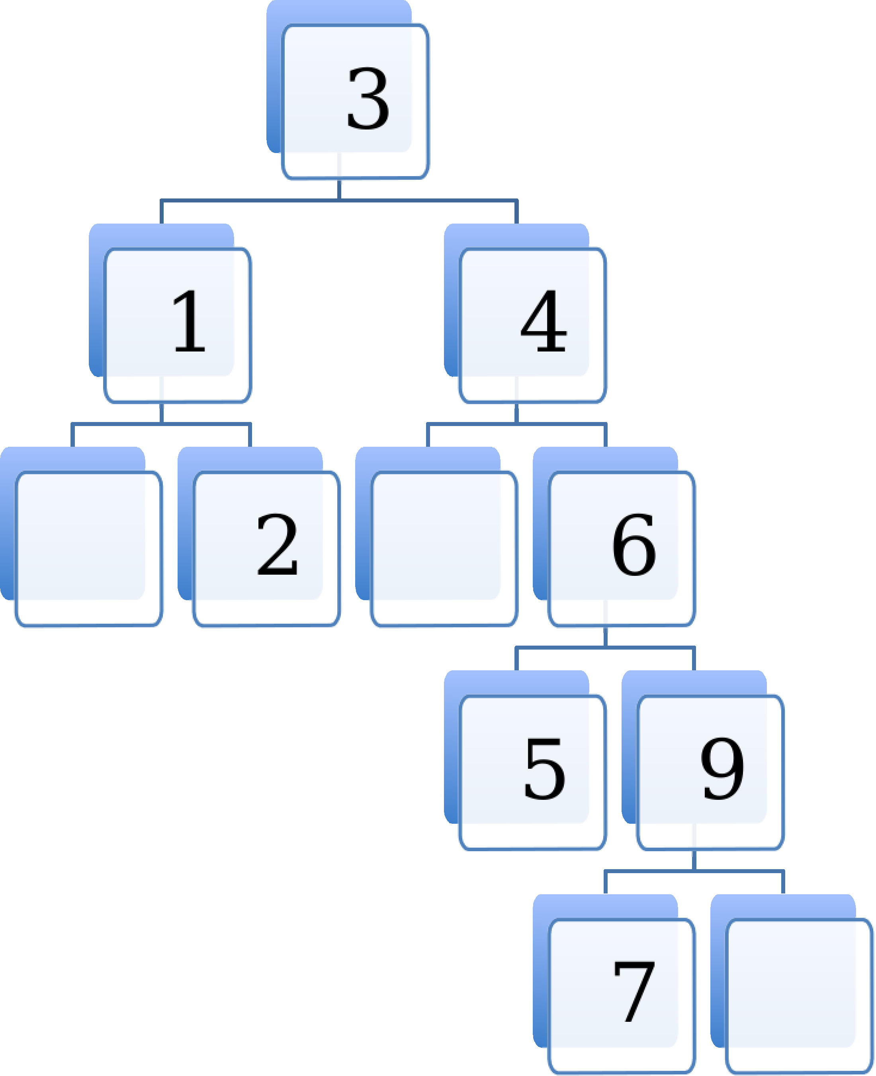
- Is the tree shown above a binary tree?
- Is it also a binary search tree?
- Is it also a balanced binary search tree?
- Explain why or why not.
- Suppose we wanted to use binary search to see if the number 8 was in the tree. What steps would be involved?
- Can we use a binary search tree to implement the Set ADT? How would we implement the “add” operation?

G. Graphs
- Suppose we have a very dense weighted graph, and will be using Prim’s algorithm to obtain a minimum spanning tree from it.
- Would it be better to use an adjacency list implementation, or an adjacency matrix implementation? Explain why.
- Are all trees also graphs? Explain why or why not.

